Installation challenges
Launched one EC2 instance using Amazon Linux 2.
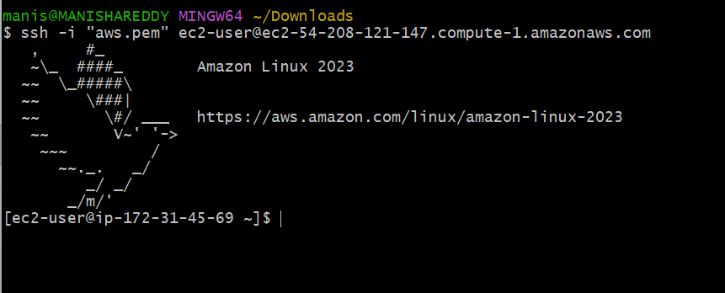
Install Docker.
Using this command Sudo -i switched to root user.
Using this command Yum install docker -y installed docker.
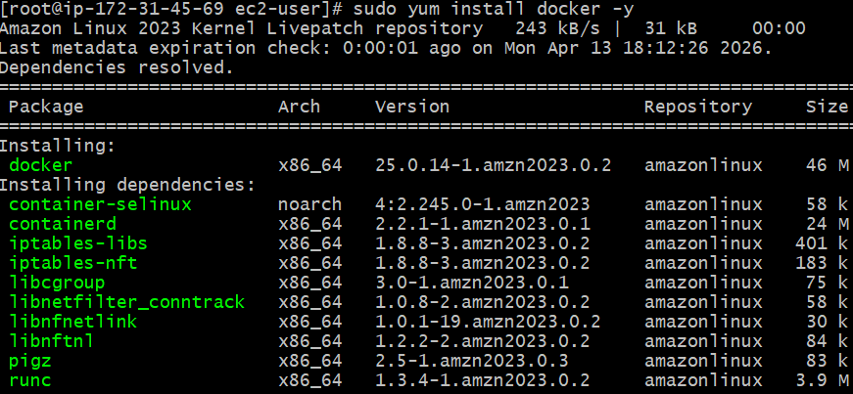
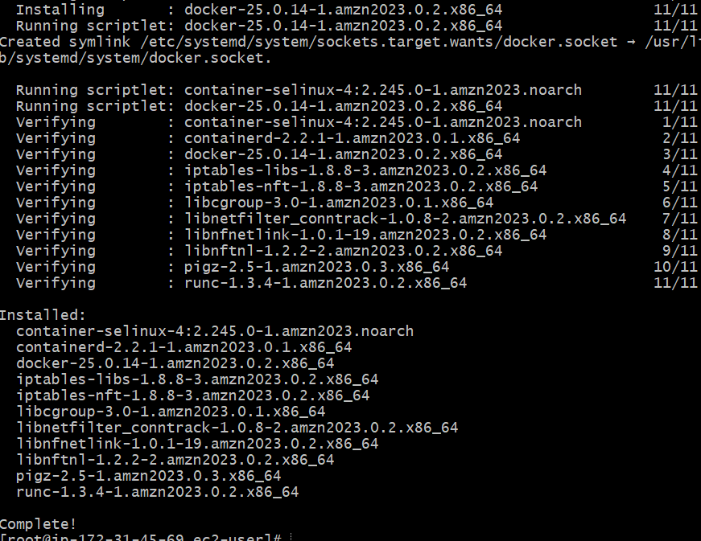
Using this command systemctl start docker started docker.
Using this command systemctl enable docker enabled docker.
To check the version docker --version
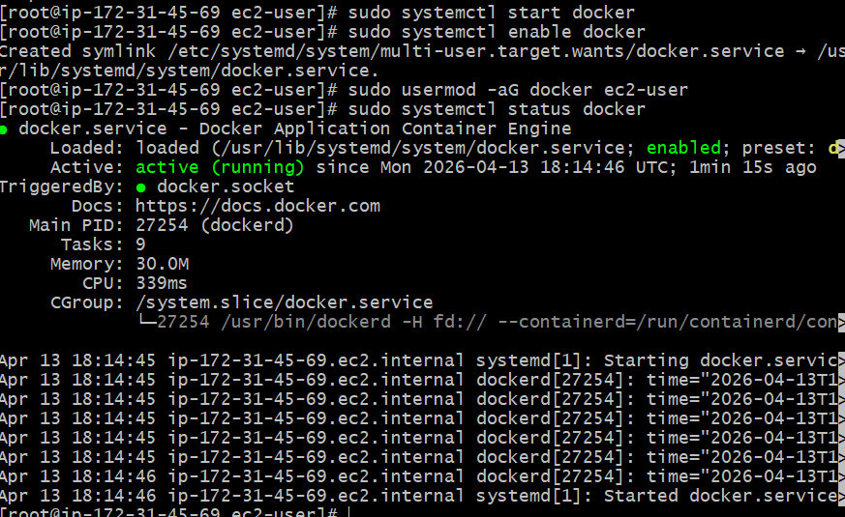

Install Jenkins
Jenkins needs java so installed java using this sudo yum install java-17-amazon-corretto -y
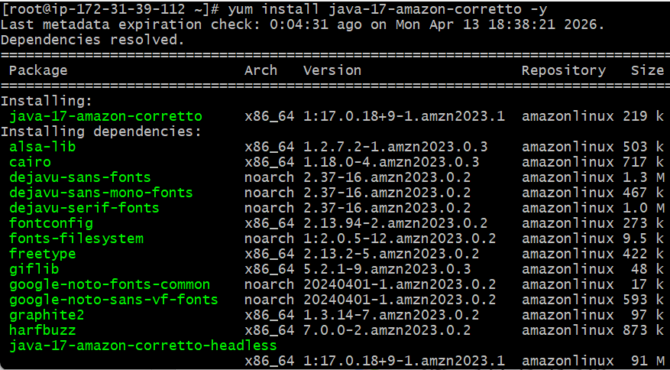
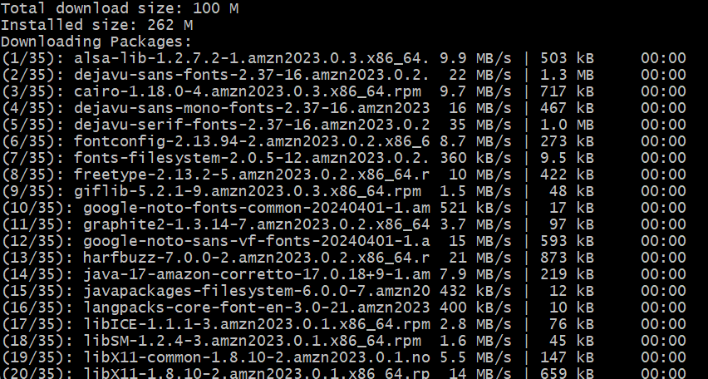
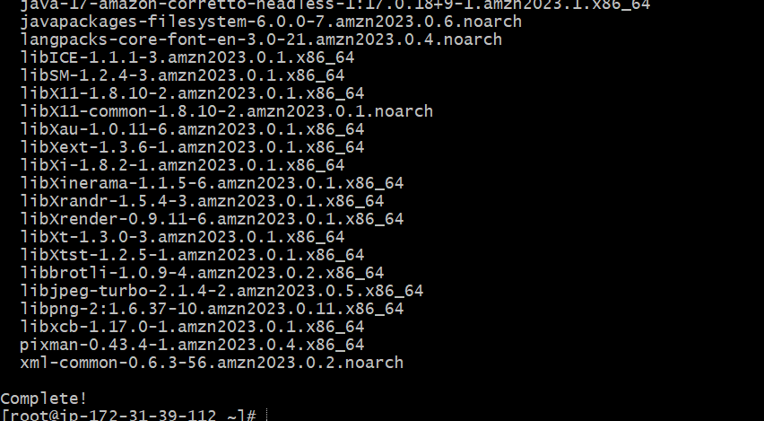
sudo wget -O /etc/yum.repos.d/jenkins.repo \
https://pkg.jenkins.io/rpm-stable/jenkins.repo
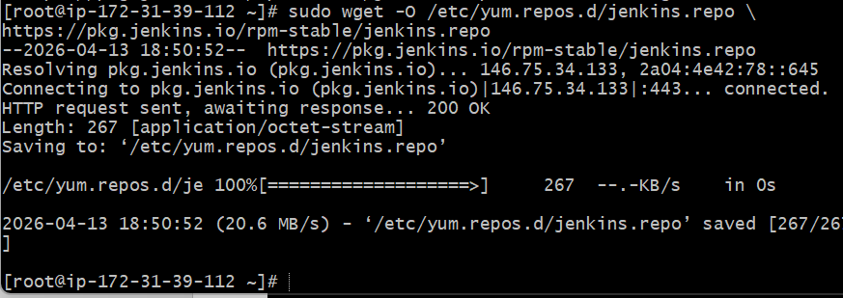

To install Jenkins yum install Jenkins

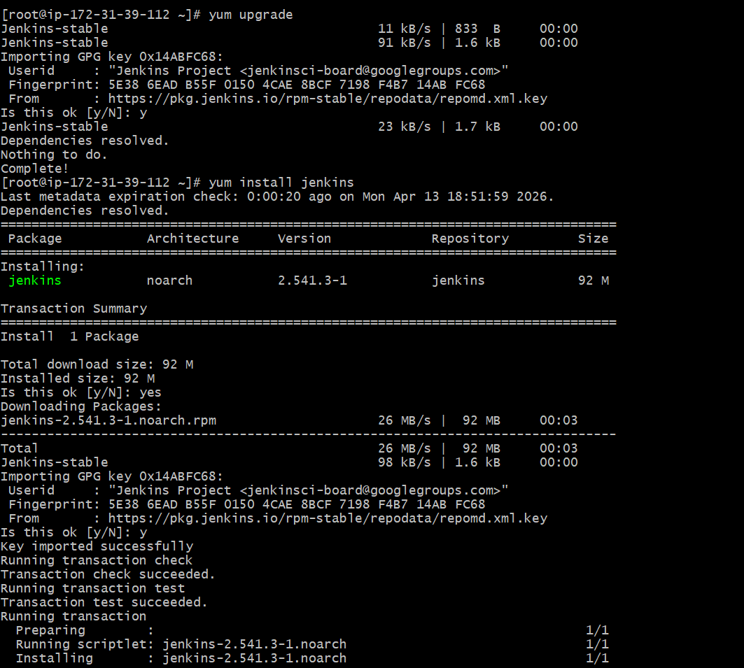

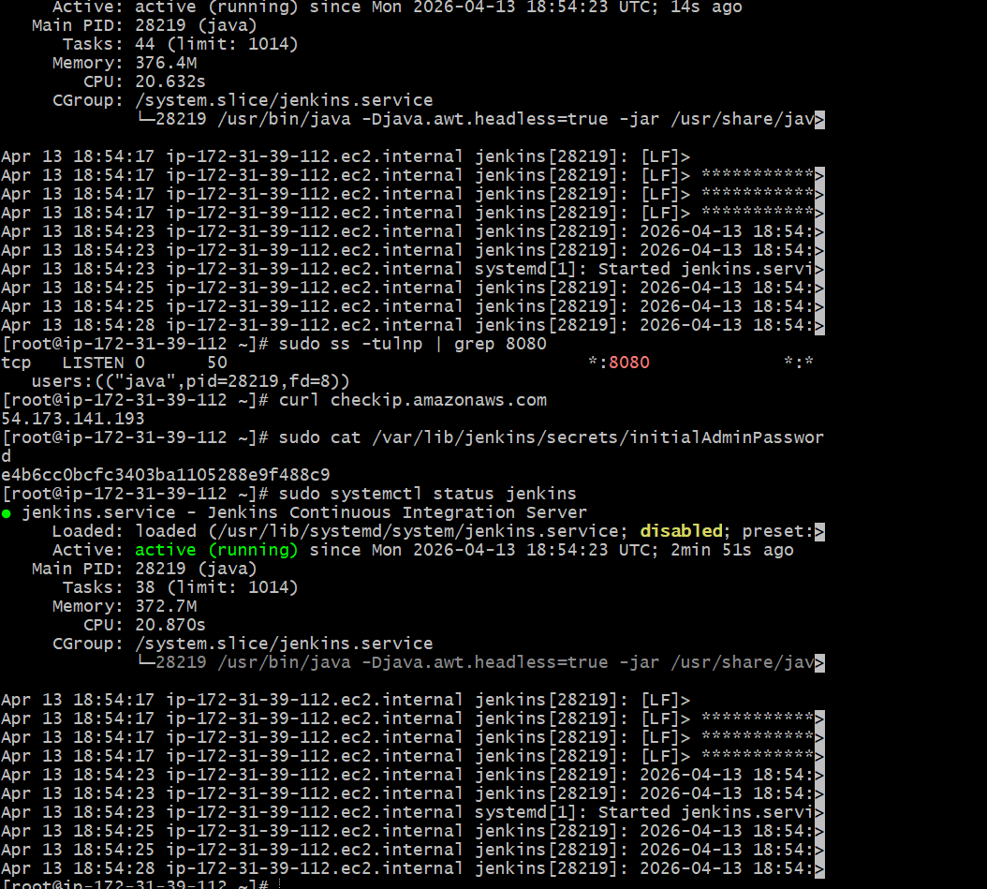
Go to AWS Console → EC2 → Security Group → Inbound Rules

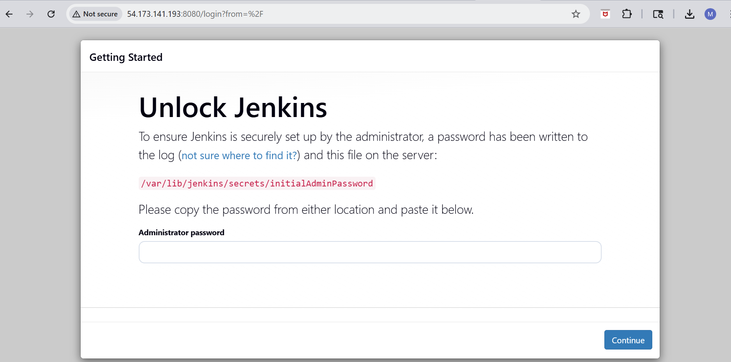
Install Apache. (httpd)
To install apache httpd sudo yum install httpd -y
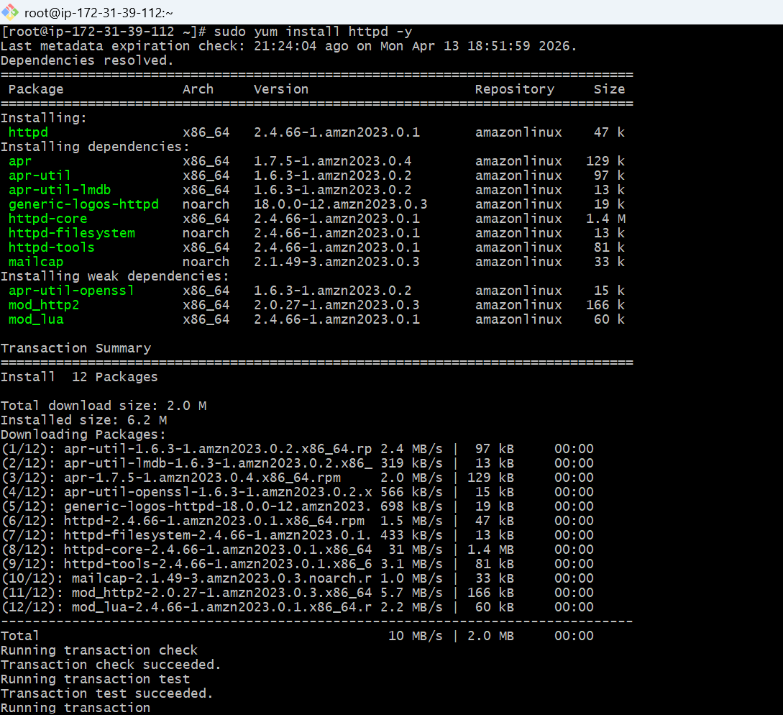
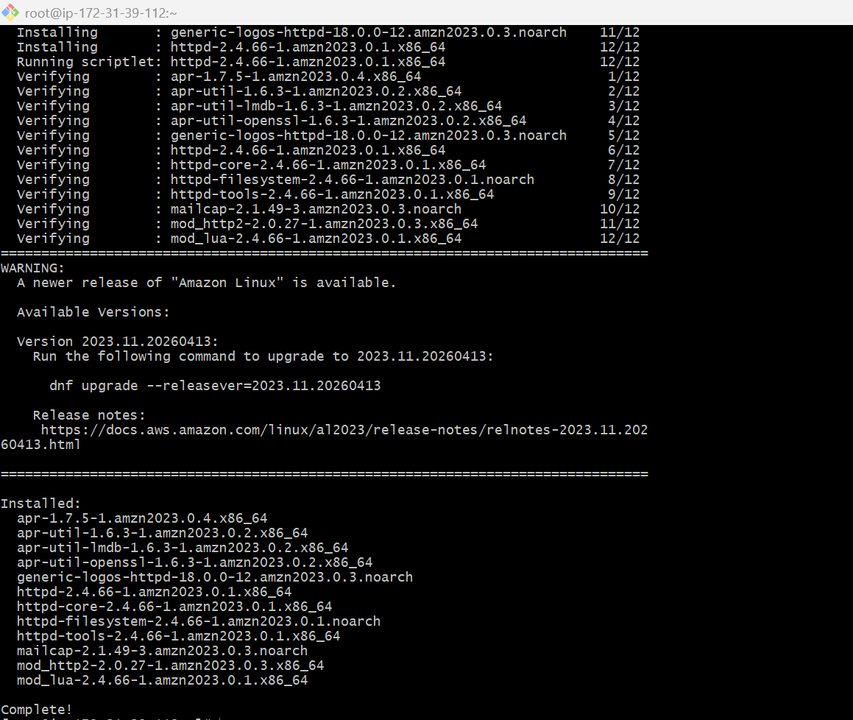
To start httpd sudo systemctl start httpd
To enable httpd sudo systemctl enable httpd
To check status sudo systemctl status httpd
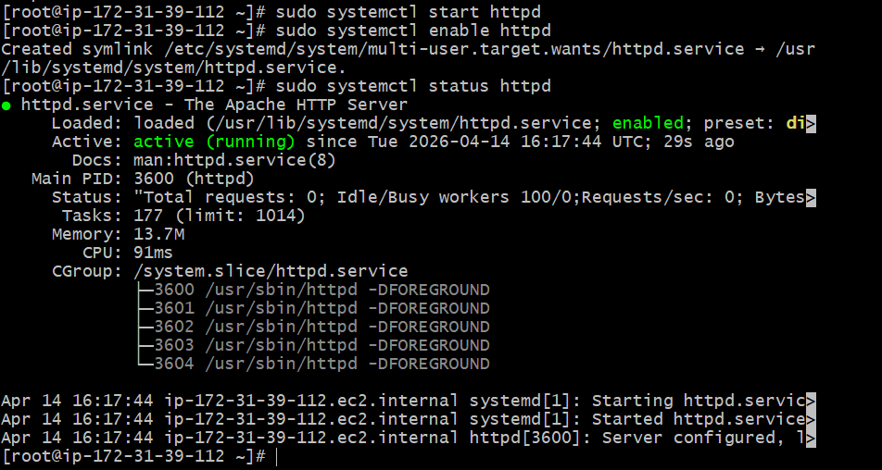
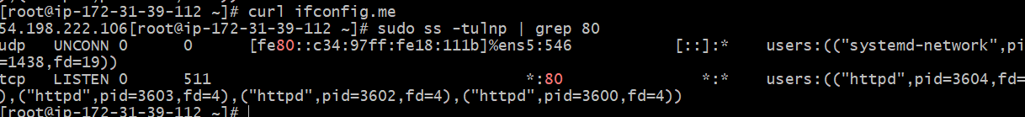
Go to AWS Console → EC2 → Security Group → Inbound Rules
Working URL
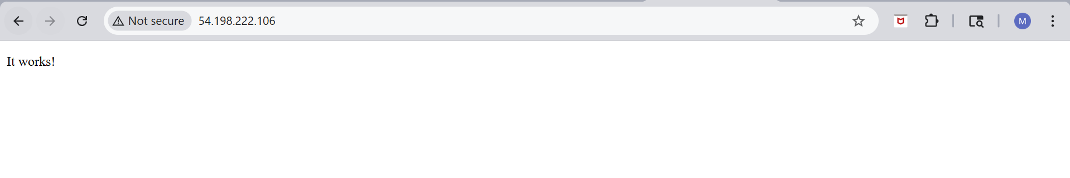
Install Nginx
To install nginx yum install nginx -y
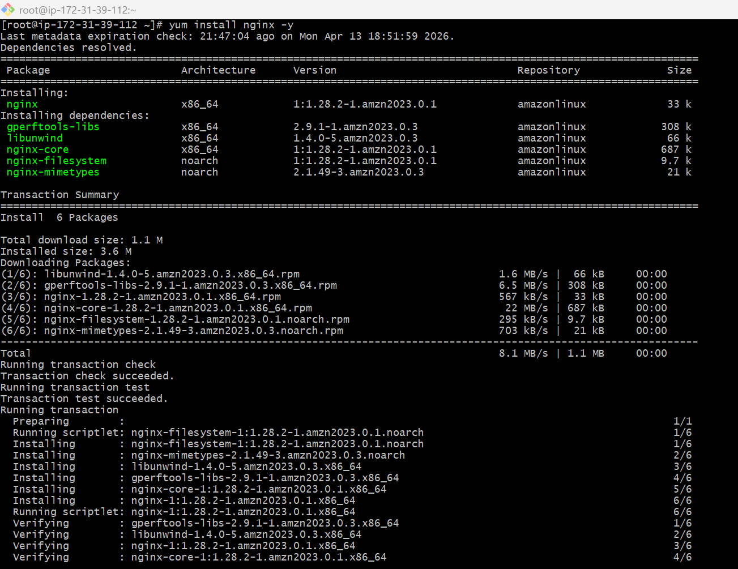
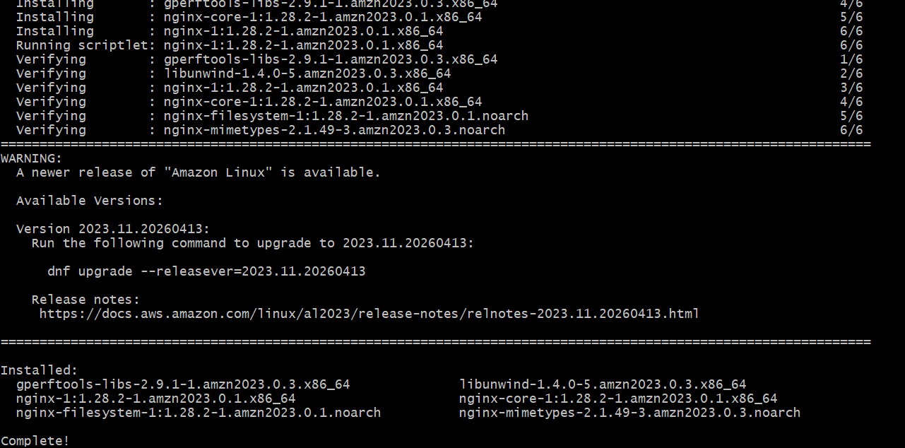
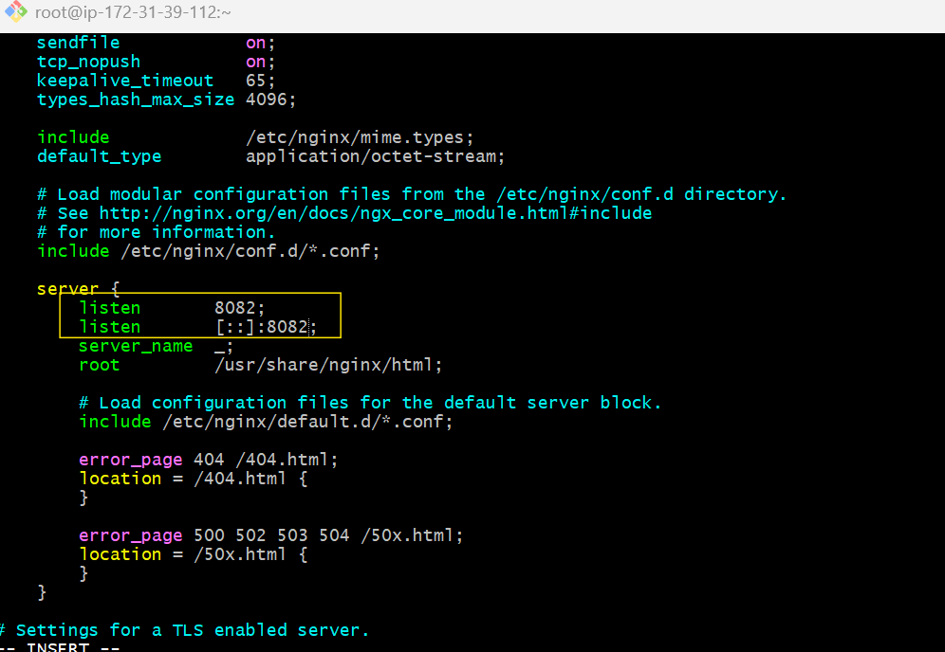
To start systemctl start nginx
To enble systemctl enable nginx
To check the status systemctl status nginx
To see the port number running or not ss -tulnp | grep 8082
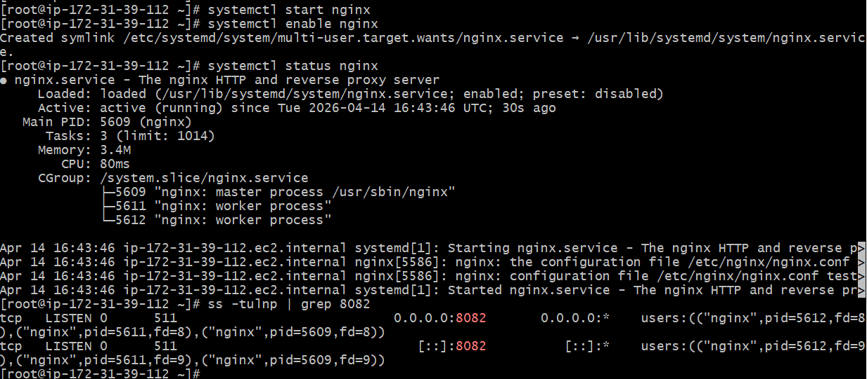
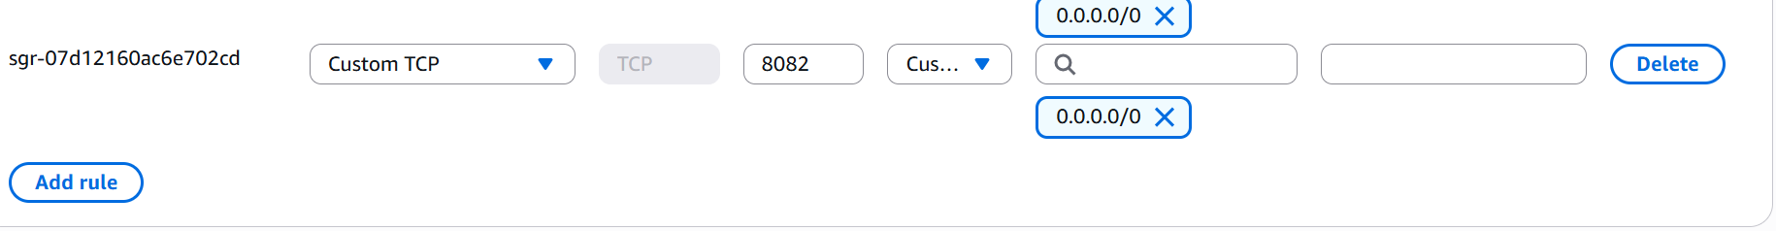
Open in Browser http://54.198.222.106:8082/
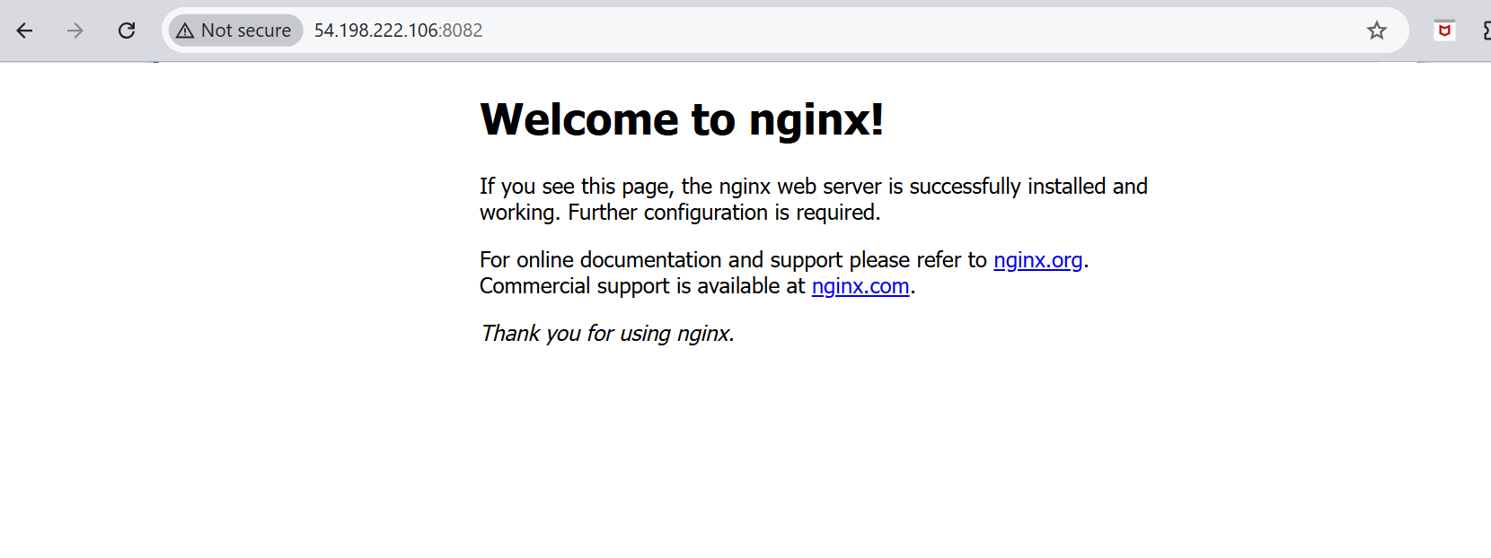
Install Apache Tomcat
To check the java version java -version
cd /opt
with this link downloaded the apache tomcat
sudo wget https://downloads.apache.org/tomcat/tomcat-9/v9.0.117/bin/apache-tomcat-9.0.117.tar.gz
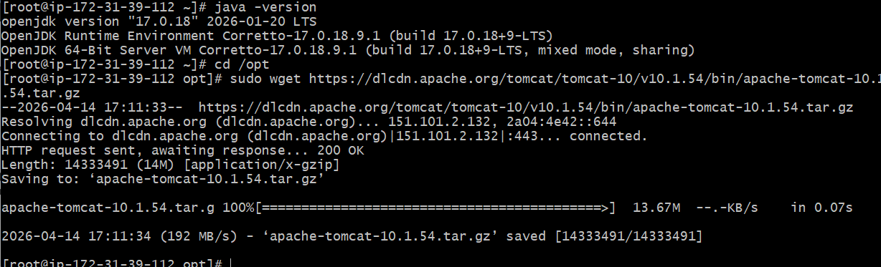
To untar the tar file using this command
sudo tar -xvzf apache-tomcat-9.0.117.tar.gz
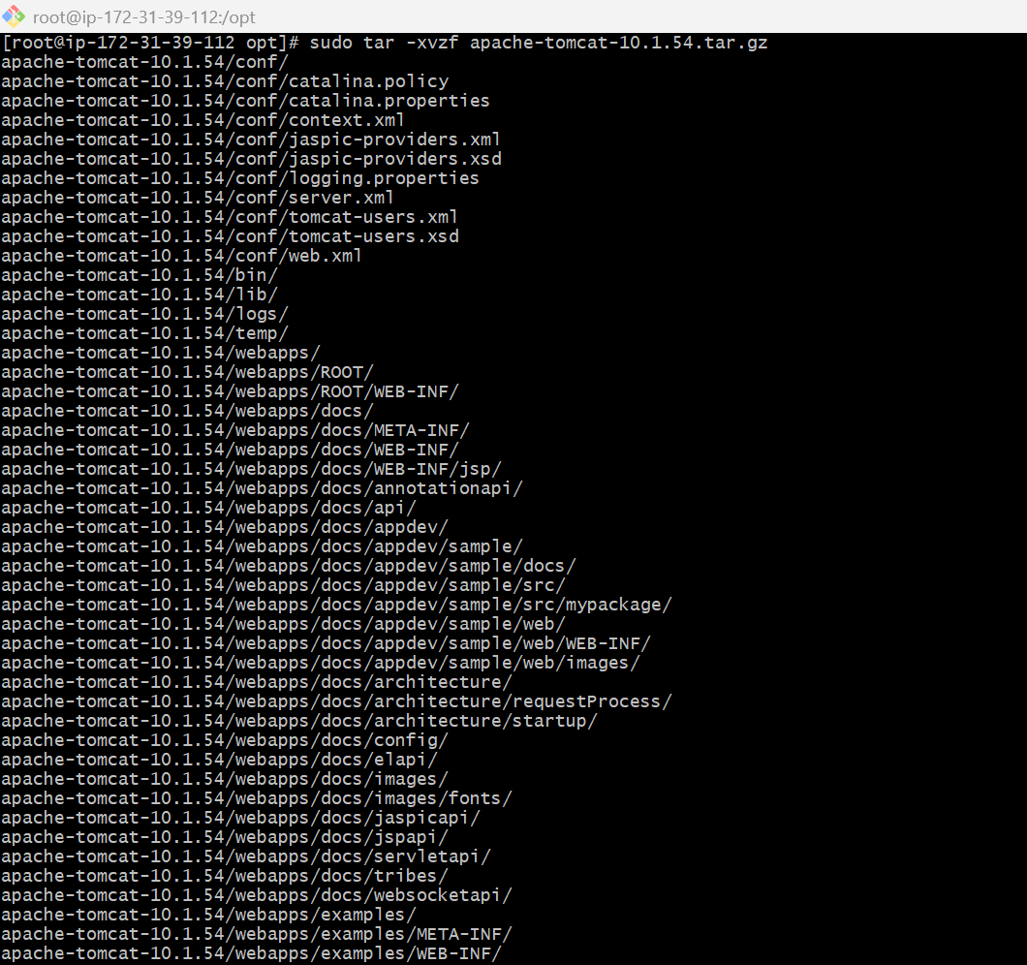
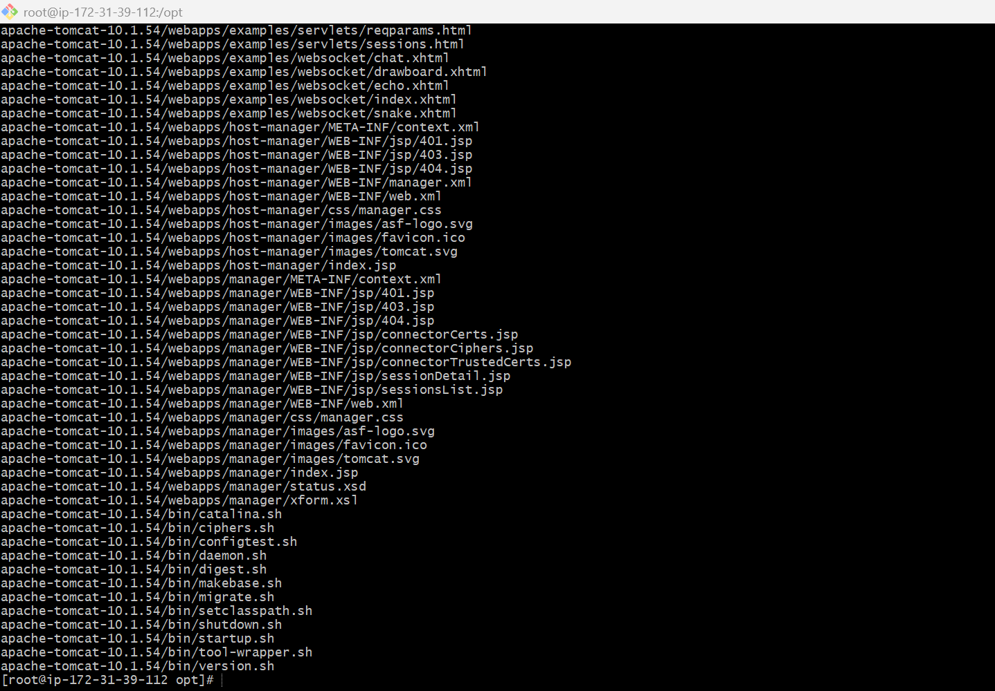
To change the name to tomcat sudo mv apache-tomcat-9.0.117 tomcat
sudo chmod +x /opt/tomcat/bin/*.sh
sudo vi /opt/tomcat/conf/server.xml
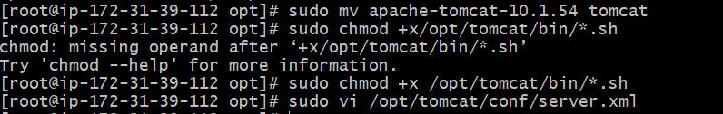
Changed Port to 8081

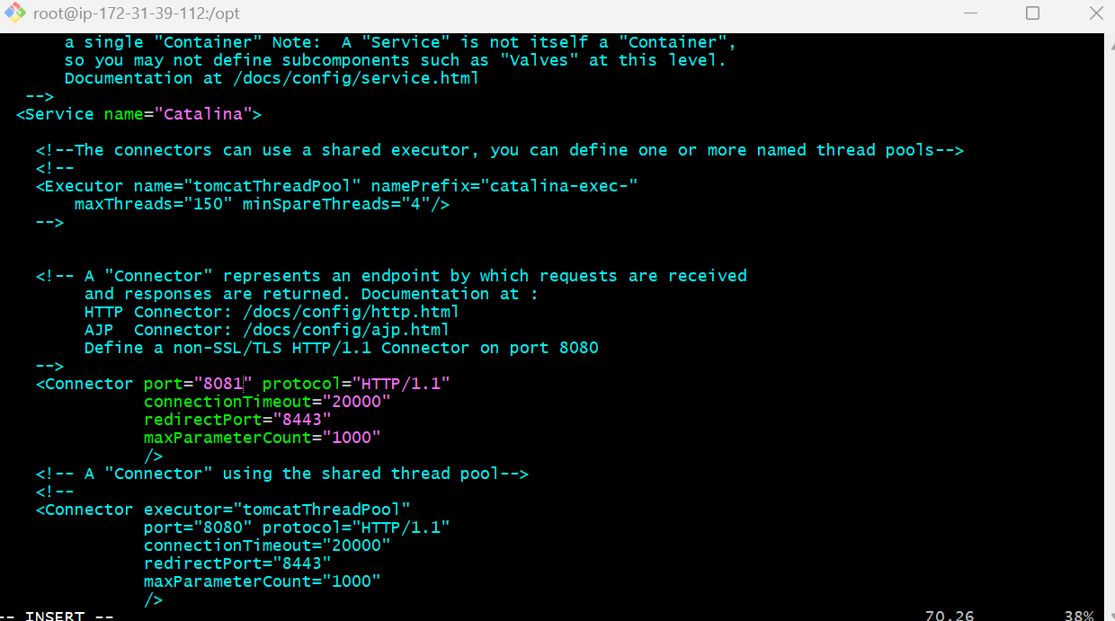
sudo /opt/tomcat/bin/startup.sh
ps -ef | grep tomcat
to grep the port number sudo ss -tulnp | grep 8081
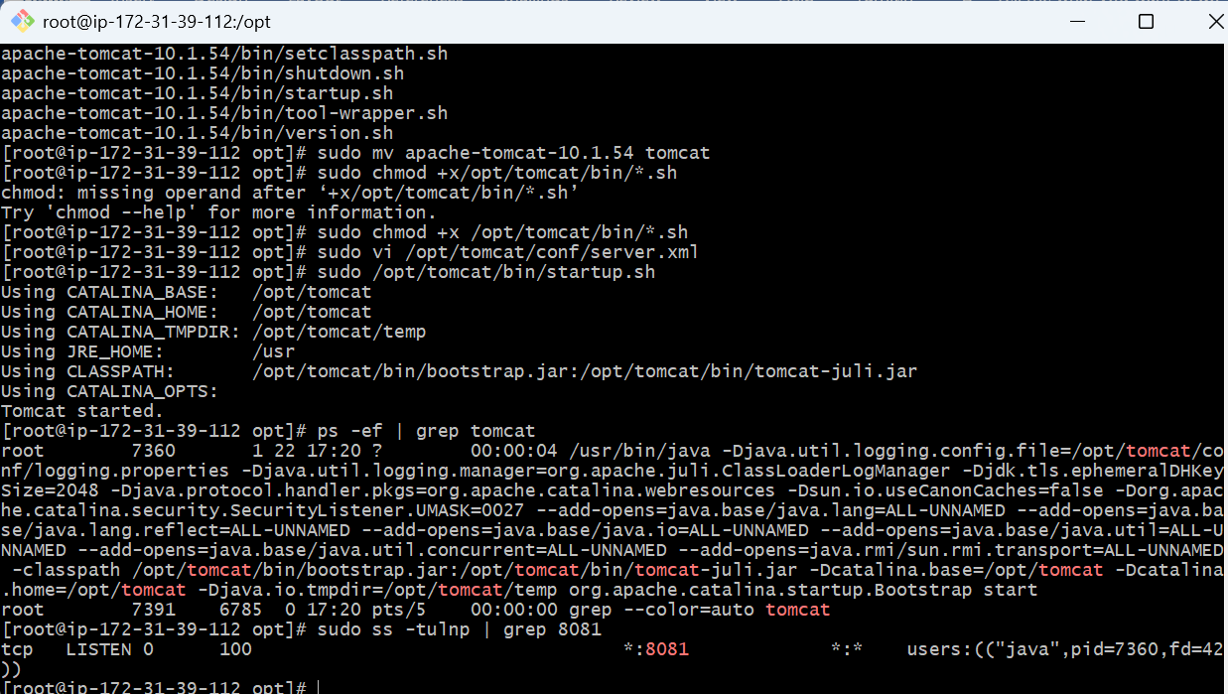
Go to AWS Console → EC2 → Security Group → Inbound Rules
